*Leo Toueg*

*20062982*

CISC 251 Exercise Sheet 1

1. Today I noticed data being collected on me everywhere. Most of what I do on a daily basis involves someone collecting data on me, as grim as that sounds. Whether it’s playing games, where you can find not only your stats being tracked, but your mouse movements for anti-cheat purposes, or surfing the internet for something you’re interested in, data is constantly being collected. When I see targeted adds on things I was just searching for, it is eye opening to the crazy data collection that is being done nowadays. Other examples include mandatory declarations of immunization, credit card information, university surveys, and google reviews.
2. I was able to set up a relatively simple workflow to look at the statistical properties of some of the data:

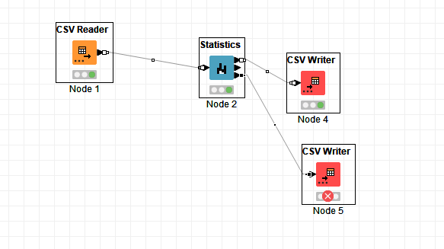

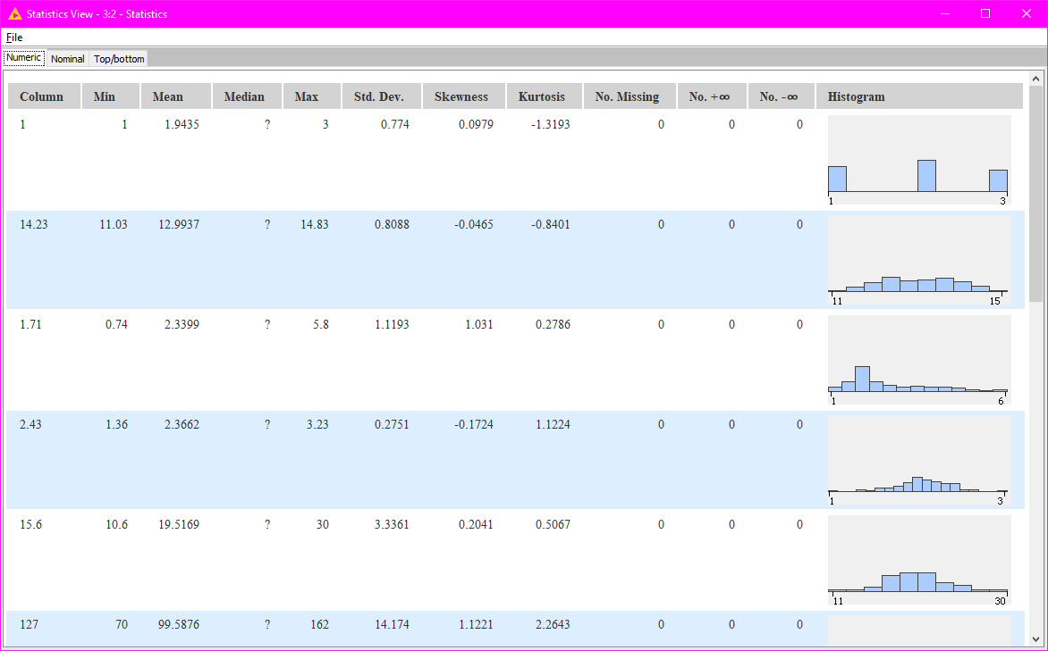

Here are some of the results from KNIME.

I’m still not very good at KNIME, I was playing arround with it and used the following workflow in order to find and graph correlations between attrributes:

